**Configuring the RN XV module to communicate in AP mode**

For this experiment you need two PCs with WiFi enabled in one and in the other PC we need to connect a RN XV module mounted on zigbee adaptor through USB cable.

Here we will communicate between two PCs through WiFi of RN XV module in one PC and inbuilt WiFi in the other PC.

**Step 1:**

In first PC connect the RN XV module to set AT command. Read the manual to enter command mode to do this.

**Step 2:**

Enter the following commands in the Tera term terminal

|  |
| --- |
| Command Comments |
| set wlan join 7 // enables access point mode |
| set ip dhcp 4 // set dhcp to mode 4, (Server) |
| set wlan chan 1 // sets the wlan channel 1 |
| set ip address 1.2.3.1 // sets the ip address to 1.2.3.1 |
| set ip netmask 255.255.255.0 // sets the netmask |
| set ip gateway 1.2.3.1 // sets the gateway IP address |
| save //saves the settings |
| reboot //reboots the module |

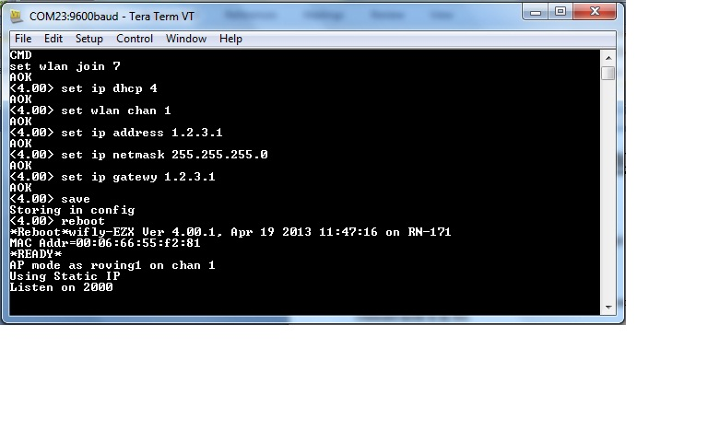

**Fig. 1 command mode settings**

**Step3:**

Now enable the inbuilt WiFi in the other PC and connect it to this RN XV module from wireless network connections.

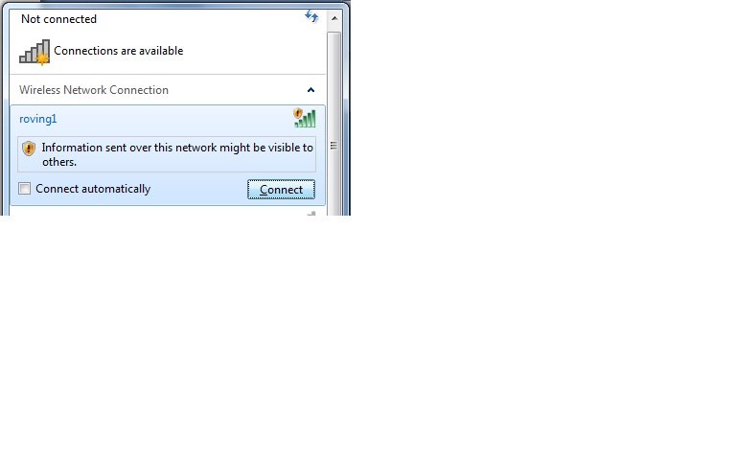

**Fig. 2 Wireless Network Connections from PC 2**

**Step 4:**

Now in the other PC open Tera term software and setup a new connection of TCP/IP type.

SET:

|  |
| --- |
| Host IP address as 1.2.3.1 |
| Service: Telnet |
| TCP port: 2000 |

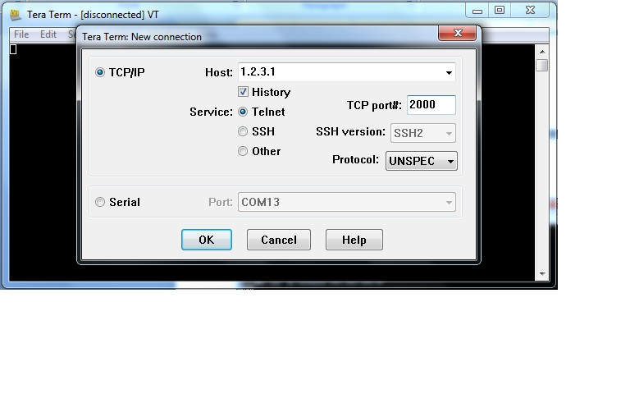

**Fig. 3 TCP/IP settings in PC2**

Press ok.

**Step 5:**

Now you can transmit message from one PC to the other through the workspace of Tera term software.

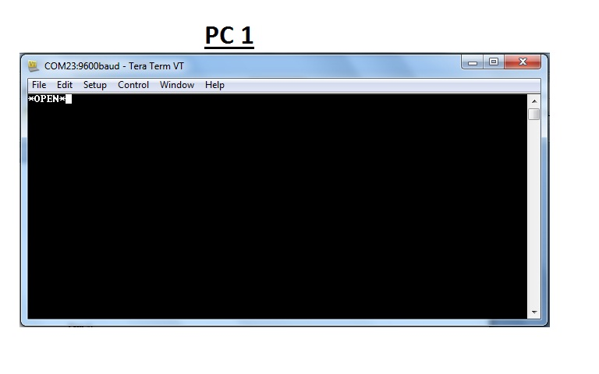

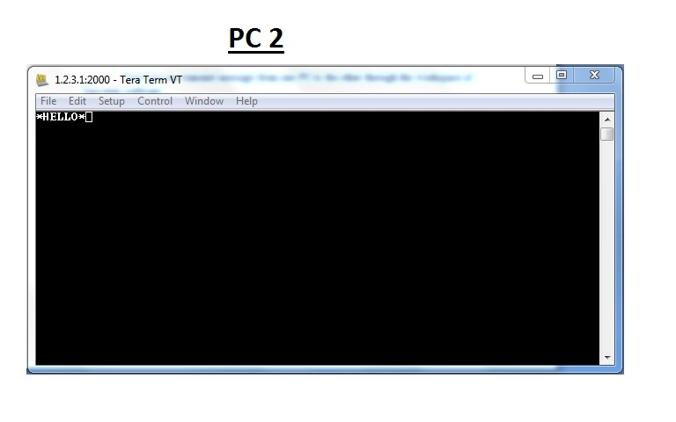

**Fig. 4 Handshake**

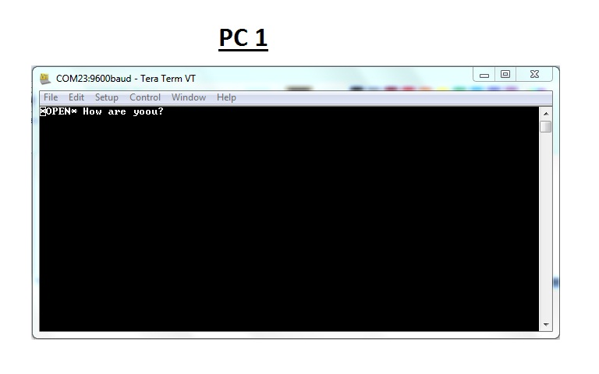

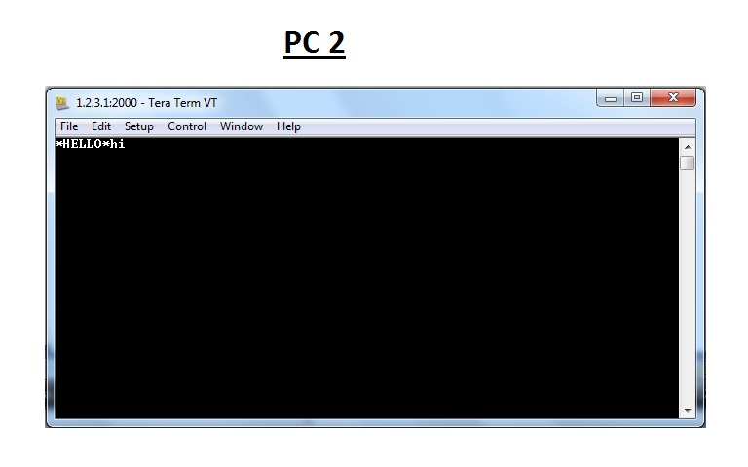

**Fig . 5 message communication**

**NOTE:**

* If you have problem setting the module in AP mode try factory resetting the module by sending factory RESET command in command mode then reconfiguring the module with above settings.

**Note: AD-HOC mode**

 As of recently there is a new 4.0 firmware for the wifly chip that no longer supports Adhoc mode. It is replaced with AP mode.